**ENHANCING ENDPOINT DIFFERENTIATION IN CDMA THROUGH VARIABLE LENGTH SPREADING**

**( VLS )**

By

***Gurshaan Singh Bhasin – 21BLC1424***

***Kevin Joshua T – 21BLC1445***

***Mohammed Shoukat Ali – 21BLC1497***

***A project report submitted to***

**Dr. VIJAYAKUMAR PEROUMAL**

**Associate Professor, School of Electronics Engineering**

in partial fulfilment of the requirements for the course of

**BCSE308 – COMPUTER NETWORKS**

in

**B.TECH ELECTRONICS AND COMMUNICATION / COMPUTER ENGINEERING**



**Vellore Institute of Technology, Chennai**

**Vandalur – Kelambakkam Road**

**Chennai – 600 127**

**November 2022**

**Chennai**

***BONAFIDE CERTIFICATE***

This is to certify that the Project work titled **“ENHANCING ENDPOINT DIFFERENTIATION IN CDMA THROUGH VARIBALE LENGTH SPREADING (VLS)”** that is being submitted by **Gurshaan Singh Bhasin(21BLC1424) , Kevin Joshua T(21BLC1445) and Mohammed Shoukat Ali(21BLC1497)** is in partial fulfilment of the requirements for the award of Bachelor **of Technology in Electronics and Communication Engineering**, is a record of bonafide work done under my guidance. The contents of this Project work, in full or in parts, have neither been taken from any other source nor have been submitted to any other Institute or University for award of any degree or diploma and the same is certified.

**Dr. VIJAYAKUMAR P**

**Guide**

**The thesis is satisfactory / unsatisfactory**

**Internal Examiner External Examiner**

Approved by Approved by

**PROGRAM CHAIR** **DEAN**

B. Tech. Electronics and Communication School of Electronics & Engineering Engineering

**ABSTRACT**

Traditional CDMA utilizes unique spreading codes assigned to each user to differentiate between them in a shared wireless system. The original data signal is spread by multiplying it with the assigned spreading code, expanding the signal's bandwidth. At the receiver, the received signal is correlated with the corresponding spreading code to extract the desired user's signal while suppressing interference. This correlation process involves multiplying and integrating the received signal with the user's spreading code. The resulting signal is processed further to remove noise and recover the original data. CDMA's use of low cross-correlation spreading codes enables multiple users to transmit simultaneously on the same frequency band, ensuring efficient and robust communication.

***Keywords :*** Pseudonoise (PN) , Variable Length Spreading (VLS) , Code Division Multiple Access (CDMA) , Endpoint Differentiation , Spreading Code , Spectral Efficiency.

**ACKNOWLEDGEMENT**

We wish to express our sincere thanks and deep sense of gratitude to our project guide, **Dr. Vijayakumar P,** Associate Professor, School of Electronics Engineering, for his consistent encouragement and valuable guidance offered to us in a pleasant manner throughout the course of the project work.

We are extremely grateful to **Dr. Susan Elias ,** Dean, School of Electronics Engineering, VIT Chennai, for extending the facilities of the School towards our project and for her unstinting support.

We express our thanks to our Head of the Department **Dr. Mohanaprasad K / Dr. T. Jayavignesh** for their support throughout the course of this project.

We also take this opportunity to thank all the faculty of the School for their support and their wisdom imparted to us throughout the course.

We thank our parents, family, and friends for bearing with us throughout the course of our project and for the opportunity they provided us in undergoing this course in such a prestigious institution.

**GURSHAAN SINGH KEVIN JOSHUA T MOHAMMED SHOUKAT ALI**

**TABLE OF CONTENTS**

|  |  |  |  |  |
| --- | --- | --- | --- | --- |
| **CHAPTER NO.** | **TITLE** | | **PAGE NO.** | |
| **1** | **INTRODUCTION** | | 7-13 | |
|  | 1.1  1.2  1.3  1.4 | Key Definitions  Objective  Contribution of Authors  Organization of the Report | | 8  12  12  12 | |
| **2** | **RELATED WORK** | | 14-18 | |
| **3** | **VARIABLE LENGTH SPREADING (VLS) FOR ENHANCED ENDPOINT DIFFERENTIATION IN CDMA SYSTEMS** | | 19-23 | |
|  | 3.1 Incorporation of VLS in CDMA System | | 20 | |
|  | 3.1.1 Algorithm for VLS Code Implementation in CDMA | | 23 | |
| **4** | **SIMULATION RESULTS AND ITS DISCUSSION** | | 24-27 | |
|  | 4.1 Coding Language | | 24 | |
|  | 4.2 Simulation parameters | | 25 | |
|  | 4.3 Performance Analysis | | 26 | |
|  |  | |  | |
| **5** | **CONCLUSION AND FUTURE WORK** | | 29-30 | |
|  | 5.1 Conclusion  5.2 Future Works | | 29  29 | |
| **6** | **REFERENCES** | | 31 | |
|  |  | |  | |

**7 APPENDIX** 32-36

Python Code

**LIST OF FIGURES**

|  |  |  |
| --- | --- | --- |
| **FIGURE NO.** | **TITLE** | **PAGE NO.** |
| 1  2  3 | The CDMA Concept  Flowchart of Implementation of VLS in CDMA  Detailed Block Diagram on working of CDMA implemented with VLS | 11  19  22 |
|  |  |  |
| 4  5  6  7 | Bit Error Rate Performance of CDMA  Signal to Interference Ratio of CDMA  Signal to Noise Ratio of CDMA  Channel Capacity | 26  27  27  28 |

**CHAPTER I**

**INTRODUCTION**

Traditional CDMA utilizes Pseudonoise (PN) spreading codes to differentiate between users in a shared wireless communication system. Each user is assigned a unique spreading code, also known as a chip sequence or pseudo-random noise sequence. To transmit data, the original data signal is multiplied (or “spread”) by the assigned spreading code. This spreading process expands the bandwidth of the signal, effectively spreading it over a wider frequency range. At the receiver side, the received signal contains the transmissions from multiple users, each multiplied by their respective spreading codes.

To recover a specific user’s signal, the receiver correlates the received signal with the corresponding spreading code assigned to that user. The correlation process involves multiplying the received signal with the user’s spreading code and then integrating (summing) the result over a specific time period. This process enhances the desired user’s signal while attenuating signals from other users, effectively separating the desired signal from the interference.

After correlation, the resulting signal is further processed to remove noise and extract the original data transmitted by the desired user. This can involve additional stages such as demodulation, error correction decoding, and data recovery. The use of spreading codes with low cross-correlation properties ensures that the interference from other users remains minimal, allowing multiple users to transmit simultaneously on the same frequency band. This characteristic of CDMA, known as “orthogonality,” is a key factor in enabling efficient and robust communication in CDMA systems.

Overall, traditional CDMA works by spreading the signals of multiple users using unique spreading codes, and then correlating the received signal with the appropriate spreading code at the receiver to extract the desired user’s signal while mitigating interference from other users. Code Division Multiple Access (CDMA) is a widely used technology for accommodating multiple users in a shared wireless communication system.

Traditional CDMA employs Pseudonoise (PN) spreading to differentiate between endpoints by spreading signals over a wide bandwidth. However, the need for improved flexibility and adaptability in CDMA systems has led to the development of Variable Length Spreading (VLS) as a complementary technique. VLS allows for dynamic adjustment of spreading code lengths for individual users, based on specific conditions or requirements.

**1.1 key Definitions**

* **CDMA:**Code Division Multiple Access (CDMA) is a digital cellular technology that enables multiple users to share the same frequency spectrum simultaneously. Unlike other multiple access techniques like Time Division Multiple Access (TDMA) or Frequency Division Multiple Access (FDMA), CDMA employs a unique spreading code for each user, allowing for concurrent transmissions on the same frequency band. This spreading code, also known as a chip sequence or pseudo-random noise sequence, spreads the user’s signal over a wider bandwidth. At the receiver side, correlation with the appropriate spreading code enables the extraction of the desired user’s signal while mitigating interference from other users. CDMA offers several advantages over alternative multiple access schemes. Firstly, it provides inherent interference rejection capabilities, as the use of unique spreading codes enables simultaneous transmissions without the need for strict time or frequency separation. Additionally, CDMA exhibits robustness against multipath fading and offers enhanced capacity by efficiently utilizing available spectrum resources.
* **Pseudo Noise:**

Pseudonoise sequences, also referred to as pseudo-random noise sequences, are deterministic sequences that exhibit statistical properties similar to random noise. These sequences possess two critical characteristics: a long period and good auto-correlation properties. The long period ensures that the sequence repeats itself after an extended period, allowing for a large number of unique codes to be generated. Good auto-correlation properties mean that the cross-correlation between two different pseudonoise sequences is low, reducing interference and improving the ability to distinguish between different users.

Pseudonoise sequences are typically generated using shift registers or feedback shift registers (FSRs). Shift registers are digital circuits capable of producing sequences based on the feedback of previous outputs. By selecting appropriate feedback taps and initial states, shift registers can generate long-period pseudonoise sequences.

Pseudonoise sequences serve as spreading codes. Each user is assigned a unique pseudonoise sequence, which is used to spread their signal over a wider frequency band. This spreading process increases the resistance of the signal to interference and improves the overall capacity of the system by allowing multiple users to simultaneously transmit on the same frequency band. Furthermore, pseudonoise sequences are used in synchronization and timing recovery. In receiver systems, the received signal is correlated with the expected pseudonoise sequence to synchronize the receiver’s clock and determine the timing of the transmitted signal. This correlation process involves multiplying the received signal with the pseudonoise sequence and integrating the result over a specific time period.

* **Endpoint differentiation:**

Endpoint differentiation refers to the practice of classifying and categorizing endpoints (devices or systems) within a network based on specific attributes or characteristics. It involves identifying and grouping endpoints based on factors such as their purpose, security requirements, user roles, or network access privileges. The purpose of endpoint differentiation is to implement different levels of security, access controls, and policies based on the specific needs and risk profiles of different types of endpoints. By treating endpoints differently, organizations can apply appropriate security measures, monitoring, and enforcement mechanisms based on the level of risk associated with each endpoint category.

* **Spreading Code:**

Spreading code, also known as a spreading sequence or a spreading waveform, refers to a specific pattern or sequence of bits used to modulate a signal before transmission. The purpose of spreading codes is to spread the bandwidth of the signal, enabling multiple signals to coexist in the same frequency spectrum.

Spreading codes are typically used in spread spectrum techniques, which are widely employed in various wireless communication technologies, including CDMA (Code Division Multiple Access) and GPS (Global Positioning System). These techniques provide benefits such as increased capacity, improved security, resistance to interference, and robustness against multipath fading.

By using different spreading codes, multiple users or devices can transmit simultaneously over the same frequency band without causing significant interference to each other. Each user’s signal is distinguished at the receiver based on the unique spreading code used during modulation.

Spreading codes also provide advantages in terms of security since the signal appears as noise-like to unauthorized receivers. Moreover, spread spectrum techniques offer improved resistance to interference and multipath effects, making them suitable for applications where robust and reliable communication is essential.

* **Spectral Efficiency:**

Spectral efficiency is a measure of how efficiently a communication system utilizes the available frequency spectrum to transmit data or information. It quantifies the amount of information that can be transmitted per unit of bandwidth or per unit of frequency spectrum.

In simpler terms, spectral efficiency represents the system’s ability to squeeze more data into a given amount of frequency spectrum. A higher spectral efficiency means that more information can be transmitted within the same bandwidth, resulting in a more efficient use of the available resources.

Spectral efficiency is typically measured in units of bits per second per Hertz (bps/Hz). It indicates the number of bits that can be transmitted over each Hertz of bandwidth.

Achieving high spectral efficiency is essential in modern communication systems due to the increasing demand for data-intensive applications and limited frequency spectrum resources. Higher spectral efficiency allows for more efficient use of the available spectrum, enabling higher data rates, increased capacity, and improved overall system performance.

* **VLS:**

Variable Length Spreading (VLS) is an innovative technique that complements traditional Code Division Multiple Access (CDMA) in wireless communication systems. In CDMA, each user is assigned a fixed-length spreading code to differentiate their signals. However, VLS introduces the concept of dynamically adjusting spreading code lengths for individual users based on specific conditions or requirements.

The goal of VLS is to optimize endpoint differentiation in CDMA systems. By allocating shorter spreading codes to users with strong signal conditions or lower interference levels, data rates and spectral efficiency can be increased. Shorter spreading codes allow for higher data transmission rates within the same bandwidth. On the other hand, users experiencing weaker signal conditions or higher interference levels are assigned longer spreading codes, which provide improved resilience against noise and interference.

VLS brings adaptability and flexibility to CDMA systems. It allows for efficient utilization of available resources by tailoring the spreading code lengths to meet varying user needs. The dynamic adjustment of spreading code lengths enables the system to allocate resources more intelligently and efficiently, resulting in improved overall system performance.

In the research paper, the concept of VLS should be further explored, highlighting its advantages and challenges. The paper may investigate the algorithms and mechanisms involved in dynamically adjusting spreading code lengths. Additionally, the impact of VLS on system performance metrics such as data rates, spectral efficiency, and interference management should be analyzed and evaluated. The research may also discuss practical implementation considerations and potential future directions for VLS in CDMA systems.

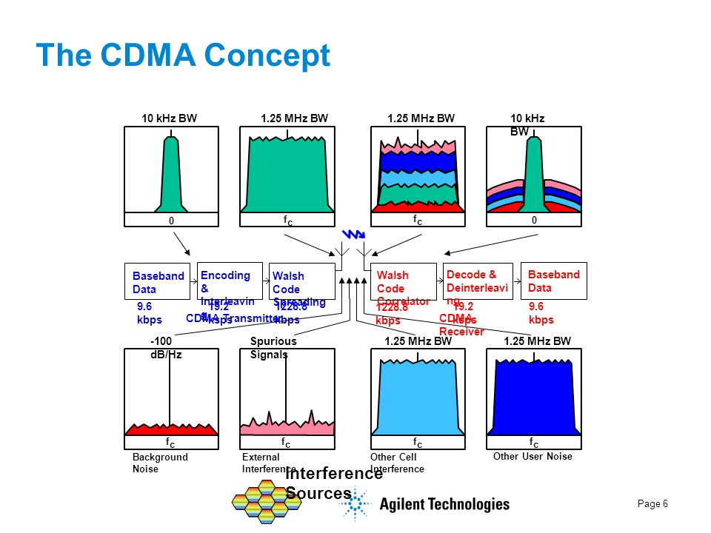

**Figure 1.**

**1.2 Objectives**

This paper aims to explores the concept of VLS and its role in enhancing endpoint differentiation in CDMA systems. By allocating shorter spreading codes to users with strong signal conditions or lower interference levels, data rates and spectral efficiency can be increased. Conversely, users experiencing weaker signal conditions or higher interference levels can be assigned longer spreading codes for improved resilience against noise and interference. VLS, when used in conjunction with PN spreading, offers a flexible approach to address diverse user requirements and optimize system performance. This abstract highlights the significance of VLS as an adaptable technique that contributes to the efficiency and reliability of CDMA systems.

**1.3 Contribution of the Authors**

After thorough analysis of over 15 research papers and many other references , as authors , we first understood the different ways to make the functionality of a CDMA System better from where we arrived at the conclusion that the Implementation of VLS , which is still currently a Topic under research , with not much concrete public data available was the most efficient out of all other techniques and one whose open research helped us make new innovations for future work.

The PPT to describe further this project along with simulation of the Results and its Inferences were all done as a group with efficient team work.

**1.4 Organization of the Project**

This paper has the following chapters :

1. Contains the **Introduction** to our project followed by –

**1. Key points** discussed to possess pre-requisite knowledge to help understand following thesis

**1. Objectives** to be achieved

**2. Contribution** of the Authors

**3. Organization** of the Project

1. Contains **Related Works**  where we have reviewed 15 research papers on the topics of CDMA Systems , Endpoint differentiations , possible modifications of VLS to be applied in future use etc.
2. Contains the **proposed variable length spreading (VLS) for enhanced endpoint differentiation in CDMA systems** and –
   1. Incorporation of VLS in CDMA Systems
      1. Algorithm for Implementation
3. Discussion and Visualizationof **Result** obtained **–**

4.1 **Coding Language**

4.2 **Simulation Parameters**

* 1. **Performance Analysis**

1. **Conclusion** of our thesis
2. **References** taken
3. **Appendix**

Python Code

**CHAPTER II**

**RELATED WORKS**

**Ayse Kortun et al [1] ;** focuses on the characteristics and functions of spreading codes in code-division multiple access (CDMA) networks. The study examines various types of spreading codes, including Pseudonoise (PN) sequences, Gold sequences, Kasami sequences, Hadamard-Walsh (orthogonal) codes, and variable-length orthogonal codes. The author explores the properties of these codes, such as auto-correlation and cross-correlation, and their impact on CDMA system performance.

**Lie-Liang Yang et al [1] ;** The paper discusses an adaptive rate-transmission scheme and its impact on effective throughput and achievable bit error rate (BER) in communication over additive white Gaussian noise channels. The results indicate that employing the VSF-assisted adaptive rate-transmission scheme can enhance effective throughput by up to 40% compared to DS-CDMA systems with constant spreading factors.

**Xia Wenlong et al [2] ;** The paper discusses blind de-spreading of long-code direct sequence spread spectrum signals (LC-DSSS) and proposes methods for estimating the spreading code in such signals. The authors introduce a heuristic segmentation-based approach that divides the received signal into shorter temporal windows and reconstructs the spreading code using covariance matrices. They combine matrix perturbation theory and run length property to determine the segmentation length. The paper also mentions existing methods for blind estimation of spreading sequences, which mostly focus on short-code DSSS signals. The authors present a segmentation-based algorithm for blind estimation but note its limitations for long-code direct-sequence code division multiple access (LC-DS-CDMA) signals. They propose a method for determining the segmentation length in the context of long-code DSSS signals. Experimental results demonstrate the effectiveness of the proposed algorithm in estimating the spreading codes of both LC-DSSS and LC-DS-CDMA signals.

**Dong In Kim ;** The paper introduces an analysis of a hybrid multicode/variable spreading factor (MC/VSF) direct-sequence code-division multiple-access (DS-CDMA) system designed for high-rate uplink transmission. The system employs precoding to achieve a constant envelope MC signal. To maximize detection gain and capture all the signal energy across the MC channels, a novel two-stage symbol group detection approach is proposed. The study investigates the symbol-error rate (SER) of the hybrid scheme, considering varying spreading factor (SF) per symbol and both identically and nonidentically distributed channel statistics. A comparison is made between the hybrid scheme and the MC option in terms of bit-error rate (BER) performance, while keeping the data rate constant and considering the receiver complexity. The hybrid MC/VSF scheme offers variable and high data rates with fewer MC channels and only a modest increase in receiver complexity. The paper also presents the system model of the hybrid scheme, highlighting its relationship with the MC option and the ability to adjust SF for increased data rates.

**Shoichiro Yamasaki et al [1] ;** The paper highlights the significance of OVSF codes in DS-CDMA systems that support multi-user/multi-rate data transmission services. It explains the representation of code sequences as code trees, where each layer corresponds to a Walsh code with a specific spreading factor. The use of Walsh codes ensures orthogonality among different code sequences, enabling efficient interference cancellation in synchronous DS-CDMA systems

**Wang Bisheng Yang Dongkai1 et al [1] ;** The paper analyzes the collision problem in Radio Frequency Identification (RFID) tags and proposes a novel scheme for an Ultra High Frequency (UHF) RFID system. The scheme combines Dynamic Framed Slotted Aloha (DFSA) with Code Division Multiple Access (CDMA) using Orthogonal Variable Spreading Factor (OVSF) codes. The proposed scheme allows for the identification of multiple tags simultaneously in a single time slot, with a maximum of m tags (the length of the OVSF code). Theoretical analysis and computer simulations demonstrate that the proposed solution significantly improves the expected system throughput compared to the classical simplex DFSA system scheme.

**Ula¸s C. Kozat et al [2] ;** This paper addresses the assignment of variable spreading gain codes in DS-CDMA wireless networks to maximize down-link system throughput. It proposes an algorithm based on code cross-correlation properties and spreading gains to allocate codes to users with different rate requirements. The goal is to enhance system throughput by considering the trade-off between high-rate codes (low spreading gain) and low-rate codes (high spreading gain) in terms of diversity gain and interference suppression. The paper focuses on the deterministic assignment of codes and presents the algorithm in Section III, taking into account the users’ minimum rate requirements.

**Po-Wei Fu et al [1] ;** This paper investigates two multi-rate access methods for multicarrier CDMA systems in the frequency domain. The study compares the performance of multi-code (MC) access and variable-spreading-length (VSL) access in uplink MC-CDMA through signal analysis and numerical simulations. While MC-CDMA has shown promise in combining CDMA and OFDM, the topic of multi-rate transmission in multi-carrier systems is relatively unexplored. The paper presents a general model for multi-rate MC-CDMA systems, accommodating both access schemes and enabling effective multi-user detection. The proposed multi-user detections are demonstrated to be effective in uplink applications, supporting multi-rate traffic. The paper illustrates the process of serial-to-parallel conversion and frequency domain spreading for both access methods. The transmitted signals are modulated onto orthogonal sub-carriers for simultaneous transmission. The formulas and illustrations provide an overview of the concepts and procedures involved in the multi-rate MC-CDMA system**.**

**Leandros Tassiulas [2] ;** This paper introduces an adaptive rate transmission scheme using variable spreading factors (VSF) to enhance the throughput of DS-CDMA systems. The study investigates the system’s effective throughput and bit error rate (BER) performance in AWGN channels. The findings demonstrate that the proposed VSF-assisted adaptive rate transmission scheme, when combined with a conventional matched filter receiver, can significantly boost the system’s effective throughput. The scheme effectively utilizes the dynamic nature of multiuser interference. The results showcase the advantages of employing VSF-assisted adaptive rate transmissions, achieving a substantial 40% increase in effective throughput by leveraging the Markovian distribution of active users in the system**.**

**Hirofumi Tsuda et al [1] ;** This paper examines the utilization of Weyl spreading sequences in CDMA systems to enhance user capacity. It demonstrates the presence of Weyl spreading sequences as orthogonal basis vectors within a bit recovering model, elucidating their superior capacity relative to Gold codes. Furthermore, the paper establishes that any spreading sequence can be represented as a combination of Weyl spreading sequences. The low interference noise exhibited by Weyl sequences is attributed to their orthogonality. Cross-correlation functions between distinct sequences are defined, and it is shown that the cross-correlation of Weyl spreading sequences approaches zero at a faster rate compared to Gold codes as the sequence length increases. The paper includes numerical outcomes comparing the bit error rate of Weyl spreading sequences and Gold codes.

**Rayleigh-Fading Channel Young Jo Bang et al [1] ;** This paper investigates the bit-error probability (BEP) of a convolutionally coded code-division multiple access (CDMA) system in a frequency-selective Rayleigh-fading channel. The study reveals that the asymptotic BEP depends on the length of the shortest error event path and the product of symbol distances along that path. Building upon this observation, a new spreading scheme is proposed to maximize the length of the shortest error event path. The scheme aims to enhance the performance of CDMA communication in the presence of multiple access interference. The paper provides a system and channel model, and discusses the proposed spreading scheme.

**Ângelo da Luz et al [3] ;** This paper introduces an analytical method to calculate the correlation between Offset Quadrature Phase-Shift Keying (OQPSK) signals modulated by different spreading sequence families. The focus is on designing efficient modulations for CDMA systems, including nonlinear amplification for power-efficient low-cost receivers. The performance of various sequence types is compared in linear and nonlinear DS-CDMA systems through simulation results. The paper highlights the importance of nonlinear amplifiers in critical communication systems and explores the correlation of spreading sequences after modulation in nonlinear systems. Additionally, alternative modulations beyond traditional PSK are considered to improve spectral efficiency and reduce the impact of nonlinearities.

**M. Kemal Karakayali et al [2] ;** This research focuses on the design of spreading sequences for CDMA systems with nonlinear OQPSK-type modulations. The paper presents an analytical method for calculating the correlation between OQPSK signals modulated by various spreading sequence families. The goal is to achieve grossly nonlinear power amplification, which enables power-efficient and cost-effective receivers for applications such as satellite, underwater, and deep space communications. The study compares the performance of different sequence types in linear and nonlinear DS-CDMA systems. The paper highlights the need to consider nonlinear amplifiers and explores alternative modulations to traditional PSK to improve spectral efficiency and mitigate nonlinearities. The simulation results demonstrate the effectiveness of the proposed sequences and their potential benefits in nonlinear CDMA systems.

**Peng-Jun Wan et al [2] ;** This paper discusses the assignment of Orthogonal Variable Spreading Factor (OVSF) CDMA codes in wireless ad hoc networks. OVSF codes consist of codewords with variable rates, unlike conventional fixed-spreading-factor CDMA codes. However, assigning OVSF-CDMA codes in ad hoc networks presents challenges due to the lack of orthogonality between all pairs of codewords. In an OVSF-CDMA ad hoc network, code assignment needs to be conflict-free, ensuring that nodes can be assigned the same codeword or non-orthogonal codewords without causing interference. The paper presents efficient methods for conflict-free code assignment in OVSF-CDMA ad hoc networks, using approximation algorithms. The use of OVSF codes allows for high-rate data service with low hardware cost, as variable-length codewords are assigned based on rate requests. The paper also highlights the differences between OVSF and conventional CDMA codes in terms of orthogonality. Channel assignment in ad hoc networks aims to avoid primary and secondary collisions, which occur when nodes transmit and receive signals on the same channel or non-orthogonal channels in the case of OVSF-CDMA.

**Mouad Addad et al [1] ;** This paper focuses on suitable spreading sequences for asynchronous Multi-Carrier Code Division Multiple Access (MC-CDMA) systems. MC-CDMA is a technology considered for next-generation wireless communication systems to achieve high data rate transmission with maintained quality. However, multi-carrier transmission systems suffer from high crest factor (CF), which is a drawback. Asynchronous MC-CDMA also experiences multiple access interference (MAI) caused by active users in the system. The spreading sequences used in CDMA systems play a crucial role in reducing CF and interference**.**

**CHAPTER III**

**PROPOSED** **VARIABLE LENGTH SPREADING (VLS) FOR ENHANCED ENDPOINT DIFFERENTIATION IN CDMA SYSTEMS**

In this paper, we propose the implementation of Variable Length Spreading (VLS) as a technique to enhance endpoint differentiation in CDMA systems. VLS allows for dynamic adjustment of spreading code lengths for individual users based on their specific signal conditions and interference levels. To illustrate the concept of VLS, we present Figure 1, which provides an overview of the VLS process in CDMA systems.

Traditional CDMA (Code Division Multiple Access) is a technique used in telecommunications to allow multiple users to share the same frequency spectrum simultaneously. In traditional CDMA, each user is assigned a unique code (known as a spreading code) that is used to spread their data across the entire available bandwidth. All users transmit their data simultaneously, and the receiver, knowing the spreading codes of the users it wants to listen to, can separate and extract the desired data from the received signals. The spreading codes act as a kind of signature that helps the receiver distinguish between different users’ transmissions, allowing for concurrent communication over the same frequency band.

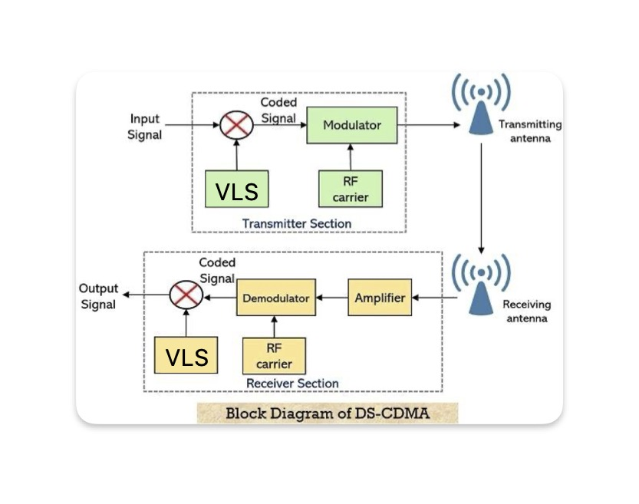

**Figure 2.**

Variable Length Spreading (VLS) is an enhancement to the traditional CDMA system that allows for more efficient spectrum utilization and improved capacity. In traditional CDMA, the spreading code length is fixed, and all users spread their data using the same code length. In contrast, VLS allows different users to use spreading codes of varying lengths. Users with higher data rates or better signal conditions can use shorter spreading codes, while users with lower data rates or worse signal conditions can use longer spreading codes. This flexibility in spreading code length allows the system to adapt to different channel conditions and user requirements, optimizing the use of available resources. VLS can significantly increase the capacity of the CDMA system and improve overall system performance, making it a valuable addition to traditional CDMA networks.

Using VLS, we expect to achieve improved endpoint differentiation by dynamically adjusting spreading code lengths based on individual user conditions. Through simulations and performance evaluations, we aim to demonstrate the enhanced data rates, spectral efficiency, and interference management capabilities provided by VLS in CDMA systems. Figure 1 provides an overview of the proposed idea for enhancing endpoint differentiation in CDMA systems through Variable Length Spreading (VLS). These illustrations and parameters offer a comprehensive understanding of the utilization of VLS in the paper. Figure 1. is a **flowchart** which allows us to better understand how the CDMA system works

* 1. **Incorporation of VLS in CDMA System**

Variable Length Spreading (VLS) is incorporated into a CDMA system by modifying the code assignment and data transmission processes. In traditional CDMA, users are assigned fixed-length spreading codes, whereas VLS allows for the assignment of spreading codes with varying lengths based on user data rates and channel conditions. Users with higher data rates or better signal quality are assigned shorter spreading codes, while users with lower data rates or poorer signal conditions are assigned longer spreading codes. During data transmission, each user spreads their signal using their designated spreading code of variable length, with shorter codes allowing for faster transmission and longer codes providing better interference resilience.

The receiver correlates the received signal with the different possible spreading codes to extract the desired user's data. Adaptive resource allocation algorithms are employed to dynamically adjust the code assignments and efficiently allocate the available spectrum based on channel conditions and user requirements. Incorporating VLS enhances the CDMA system's flexibility, spectral efficiency, capacity utilization, and overall performance in varying scenarios.

By incorporating Variable Length Spreading (VLS) into a CDMA system , as seen in Figure 3. Code assignment and data transmission are modified to accommodate spreading codes of different lengths. VLS allows users to be assigned spreading codes based on their data rates and channel conditions, with shorter codes for higher data rates and better signals, and longer codes for lower data rates and weaker signals. During data transmission, each user spreads their signal using their designated spreading code of variable length, enabling faster transmission or better interference resilience. The receiver correlates the received signal with different spreading codes to extract the desired user's data. Adaptive resource allocation algorithms are employed to dynamically adjust code assignments and efficiently allocate the spectrum. VLS enhances the CDMA system's flexibility, spectral efficiency, capacity 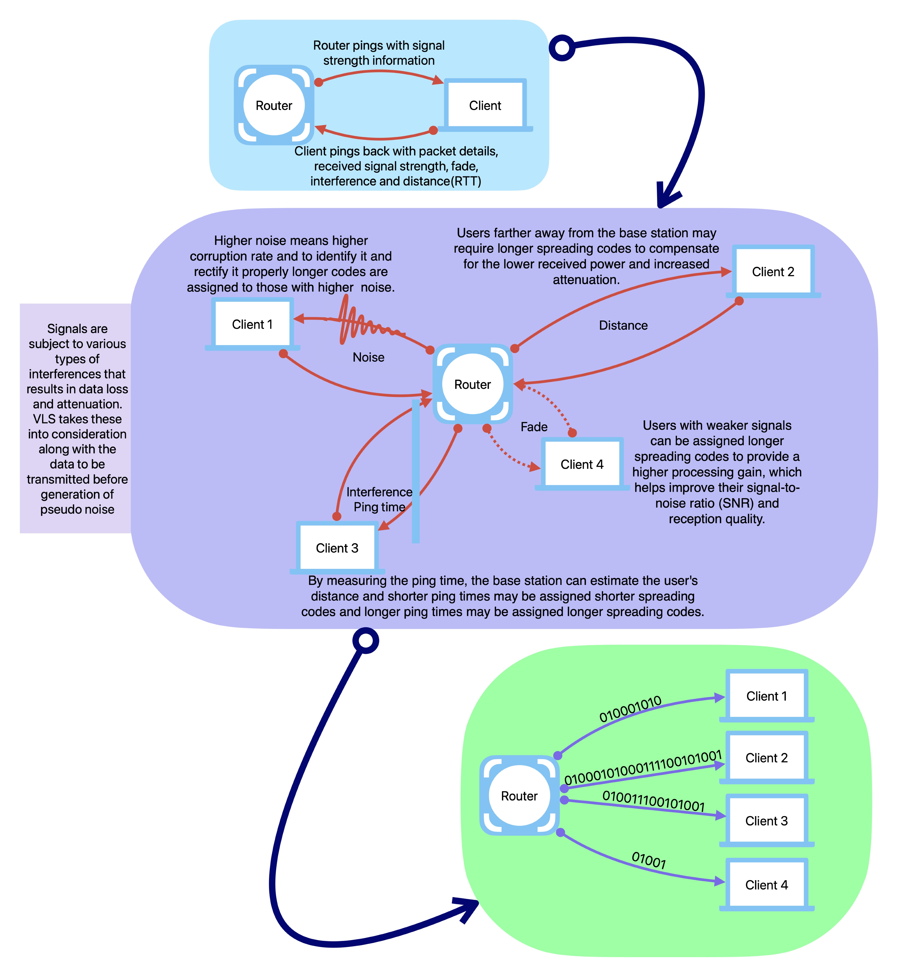utilization, and performance in various scenarios.

**Figure 3.**

* + 1. **Algorithm for VLS Code Implementation in CDMA**

STEP 1) Initialize the system parameters:

- Set the available spreading code lengths, such as L_short for shorter codes and L_long for longer codes.

- Determine the threshold values for signal strength and interference level.

STEP 2) For each user in the CDMA system:

a. Measure the user's signal strength and interference level.

b. Calculate the signal assessment metric, such as Signal-to-Interference Ratio (SIR), based on the measurements.

STEP 3) If the SIR is above the signal strength threshold:

a. Assign the user a shorter spreading code length (L_short) for higher data rates and improved spectral efficiency.

b. Proceed to the next user.

STEP 4) If the SIR is below the signal strength threshold:

a. Assign the user a longer spreading code length (L_long) for improved resilience against noise and interference.

b. Proceed to the next user.

STEP 5) Transmit user data using the allocated spreading codes for simultaneous communication within the CDMA system.

STEP 6) Continuously monitor the signal conditions of users and dynamically adapt the spreading code lengths based on changes in signal strength and interference levels.

STEP 7) Repeat steps 2 to 6 for the duration of the CDMA system operation.

The algorithm adjusts the spreading code lengths dynamically based on the signal conditions and interference levels experienced by individual users. Users with strong signal conditions or lower interference levels are assigned shorter spreading codes, maximizing data rates and spectral efficiency. Users with weaker signal conditions or higher interference levels are assigned longer spreading codes to enhance resilience against noise and interference. This dynamic adaptation allows for efficient utilization of system resources and improved performance in CDMA systems.

**CHAPTER IV**

**SIMULATION / IMPLEMENTATION RESULTS**

**4.1 Coding language**

Python can be a suitable choice for implementing Variable Length Spreading (VLS) for several reasons , namely :

1. Ease of implementation - Python's simplicity and clean syntax make it easy to implement algorithms like VLS. VLS involves manipulating arrays and performing mathematical operations, which are well-supported by Python's built-in data structures and libraries like NumPy , which is what we too have utilized to help achieve a successful outcome. Python's high-level nature allows for straightforward code that closely matches the problem domain.
2. Availability of scientific computing libraries - Python has a rich ecosystem of scientific computing libraries, including NumPy, SciPy, and scikit-learn. These libraries provide efficient numerical operations, linear algebra routines, statistical functions, and machine learning tools. These capabilities are valuable when working with VLS, as you can leverage existing functions and algorithms to streamline your implementation.
3. Visualization and data analysis capabilities - Python's libraries, such as Matplotlib and Seaborn, offer powerful data visualization capabilities. You can use these libraries to analyze and visualize the results of your VLS implementation, allowing for deeper insights and better understanding of the system's behavior. We have used this to visualize our code’s efficiency as seen by 2. i) and ii) where we use the plot function to display a comparison and output the Multiclient encoding and decoding efficiency as well as the Bit Error Rate and the Signal to Interference ratio.
4. Rapid prototyping and experimentation - Python's interactive nature and support for Jupyter Notebooks enable rapid prototyping and experimentation. You can quickly write and test code snippets, explore different variations of your VLS implementation, and iteratively refine your solution. This flexibility is particularly useful for algorithm development and performance evaluation.
5. Integration capabilities - Python's versatility allows for easy integration with other languages and systems. If you have existing code or components written in other languages, you can incorporate them into your Python-based VLS implementation using interfaces like ctypes or by calling external executables. This interoperability is valuable when working in a larger system or when collaborating with others using different technologies.

Overall, Python's combination of readability, extensive libraries, rapid development capabilities, cross-platform support, community support, and integration capabilities make it a suitable language for scientific computing, algorithm development, and prototyping tasks like the one presented in the code.

**4.2 Simulation Parameters**

The simulation parameters taken into consideration are :

* + - 1. BER (Bit Error Rate): BER is a measure of the number of bits that are incorrectly received or decoded in a data transmission system. It quantifies the quality of a digital communication channel or link by indicating the probability of bit errors occurring during data transmission. The lower the BER, the better the signal quality and the more reliable the communication.
      2. SIR (Signal-to-Interference Ratio): SIR is a ratio that measures the strength of the desired signal compared to the interference or noise present in the communication channel. It is commonly used in wireless communication systems to assess the quality of the received signal. A higher SIR indicates a better signal-to-noise ratio and, therefore, a more reliable communication link.
      3. SNR (Signal-to-Noise Ratio): SNR is similar to SIR but takes into account all sources of noise, not just interference. It is the ratio of the power of the desired signal to the power of the background noise in the communication channel. A higher SNR signifies a stronger signal relative to the noise, leading to better communication performance.

4. Channel Capacity: Channel capacity refers to the maximum data rate at which information can be reliably transmitted over a communication channel without exceeding a specified error rate. It is influenced by various factors, including the available bandwidth, signal power, and the level of noise and interference present in the channel. The channel capacity is typically measured in bits per second (bps) and is an essential concept in information theory.

**4.3 Performance Analysis**

**Figure 4.**

From Figure 4. it is clearly inferred that upon implementation of VLS in CDMA , the Bit Error Rate (BER) significantly reduces compared to the traditional CDMA System without implementation of VLS , i.e with the regular PN function generation

**Figure 5.**

From Figure 5. it is inferred that much less interference is encountered when VLS is implemented in the CDMA as compared to traditional CDMA Systems.

**Figure 6.**

From Figure 6. we infer that similar to Interference , much lesser Noise is generated when VLS is incorporated in the CDMA System as compared to when the traditional CDMA is utilized.

**Figure 7.**

From Figure 7. we infer that after implementation of VLS in CDMA a much more stable and uniform Chanel Capacity is obtained , further solidifying the purpose of the project and prove how its implementation is of great advantage.

**CHAPTER V**

**CONCLUSION AND FUTURE WORKS**

**5.1 Conclusion**

In conclusion, the proposed algorithm for Variable Length Spreading (VLS) in CDMA systems offers a dynamic and adaptable approach to enhance endpoint differentiation. By adjusting spreading code lengths based on individual user signal conditions and interference levels, the algorithm optimizes system performance and improves user experiences. Shorter spreading codes are allocated to users with strong signals and low interference, increasing data rates and spectral efficiency. Conversely, longer spreading codes are assigned to users with weaker signals or higher interference, improving resilience against noise and interference. Through simulations and performance evaluations, it is expected that the VLS algorithm will demonstrate improved data rates, spectral efficiency, and interference management capabilities in CDMA systems. The VLS algorithm, when integrated into CDMA systems, has the potential to enhance the efficiency, reliability, and overall performance of wireless communication networks.

**5.2 Future works**

1. Performance Analysis and Optimization : Researchers can investigate the performance of VLS in CDMA systems under various scenarios, such as different spreading factor configurations, user densities, traffic patterns, and environmental conditions. The goal would be to optimize the design parameters of VLS to achieve enhanced system capacity, spectral efficiency, and overall performance.

2. Interference Mitigation : Future works can focus on utilizing VLS as a means of interference mitigation in CDMA networks. By dynamically adjusting the spreading factor based on interference levels and user distribution, VLS may potentially help reduce co-channel interference and improve the overall quality of service.

3. Adaptive VLS Techniques: Similar to VLS in other communication systems, adaptive algorithms can be developed for CDMA that can dynamically adjust the spreading factor on a per-user or per-cell basis. These adaptive techniques can help allocate resources efficiently and react to changing network conditions.

5. VLS in 5G and Beyond : As 5G and future generations of wireless communication networks continue to evolve, researchers may explore the integration of VLS into these advanced systems. Evaluating the potential benefits and challenges of using VLS in 5G and beyond can lead to new insights and design possibilities.

6. Security and Privacy Considerations : The use of VLS in CDMA systems may raise security and privacy concerns due to its variable spreading factor nature. Future works could investigate potential vulnerabilities and develop countermeasures to ensure the security and privacy of users.

7. VLS-Based Multi-Access Schemes : Researchers can explore innovative multi-access schemes that incorporate VLS as a key component. This could include investigating the combination of VLS with other multiple access techniques, such as OFDMA (Orthogonal Frequency Division Multiple Access) or NOMA (Non-Orthogonal Multiple Access).

**CHAPTER VI**

**REFERENCES**

[1] Ayse Kortun – Detection of Spreading Codes in CDMA

[2] Lie-Liang Yang and Lajos Hanzo - Adaptive Rate DS-CDMA Systems Using Variable Spreading Factors

[3] Xia Wenlong , Zhou Yuanping , Meng Qingdang - Run‐length method for determining the segmentation length based on the segmentation long‐code blind estimation

[4] Dong In Kim - Analysis of a Hybrid Multicode/Variable Spreading Factor DS-CDMA System With Two-Stage Group Detection

[5] YAMASAKI and Tomoko K. MATSUSHIMA - Complex Orthogonal Variable Spreading Factor Codes Based on Polyphase Sequences

[6] Wang Bisheng ,Yang Dongkai1, and Zhang Qishan - Efficient Identification UHF RFID system scheme based on combination of DFSA and OVSF-CDMA

[7] Ula¸s C. Kozat, Iordanis Koutsopoulos and Leandros Tassiulas - Dynamic code assignment and spreading gain adaptation in synchronous CDMA wireless networks

[8] Po-Wei Fu and Kwang-Cheng Chen - Multi-Rate Multi-Carrier CDMA with Multiuser Detection for Wireless Multimedia Communications

[9] Hirofumi Tsuda and Ken Umeno - Orthogonal basis spreading sequence for optimal CDMA

[10] Mouad Addad and Ali Djebbari - Suitable Spreading Sequences for Asynchronous MC-CDMA Systems

**CHAPTER VII**

**APPENDIX**

**Python Code**

import numpy as np

import matplotlib.pyplot as plt

# Variable Length Spreading using random codes

def variable_length_spreading(data, code):

return data[:, np.newaxis] * code

# CDMA decoding for Variable Length Spreading

def vls_cdma_decode(received_signal, code):

return np.sum(received_signal * code, axis=0) / code.shape[0]

# CDMA decoding for Traditional CDMA

def traditional_cdma_decode(received_signal, code):

return np.sum(received_signal * code, axis=1) / code.shape[1]

# Calculate Bit Error Rate (BER)

def calculate_BER(original_data, decoded_data):

errors = np.count_nonzero(original_data != decoded_data)

ber = errors / len(original_data)

return ber

# Calculate Signal-to-Interference Ratio (SIR)

def calculate_SIR(received_signal, code):

signal_power = np.sum(received_signal ** 2)

interference_power = np.sum((received_signal - np.tile(code, (received_signal.shape[0] // code.shape[0], 1))) ** 2)

sir = 10 * np.log10(signal_power / (interference_power + 1e-10))

return sir

# Calculate Signal-to-Noise Ratio (SNR)

def calculate_SNR(received_signal, noise_signal):

signal_power = np.sum(received_signal ** 2)

noise_power = np.sum(noise_signal ** 2)

snr = 10 * np.log10(signal_power / (noise_power + 1e-10))

return snr

# Calculate Channel Capacity

def calculate_capacity(snr):

capacity = 0.5 * np.log2(1 + snr)

return capacity

# CDMA system parameters

num_users = np.arange(1, 11) # Number of users

data_length = 1000 # Length of data for each user

code_length = 1000 # Length of spreading code

noise_std = 0.1

vls_ber_values = []

vls_sir_values = []

vls_snr_values = []

vls_capacity_values = []

traditional_ber_values = []

traditional_sir_values = []

traditional_snr_values = []

traditional_capacity_values = []

for num in num_users:

# Generate random data and codes for each user

data = np.random.randint(low=-1, high=2, size=(num, data_length))

vls_code = np.random.randint(low=-1, high=2, size=(num, code_length))

traditional_code = np.tile(vls_code, (1, data_length // code_length))

# Variable Length Spreading

vls_spread_data = variable_length_spreading(data, vls_code)

vls_received_signal = vls_spread_data + np.random.normal(0, noise_std, vls_spread_data.shape)

vls_decoded_data = vls_cdma_decode(vls_received_signal, vls_code)

vls_ber = calculate_BER(data, vls_decoded_data)

vls_sir = calculate_SIR(vls_received_signal, vls_code)

vls_snr = calculate_SNR(vls_received_signal, np.random.normal(0, noise_std, vls_received_signal.shape))

vls_capacity = calculate_capacity(vls_snr)

vls_ber_values.append(vls_ber)

vls_sir_values.append(vls_sir)

vls_snr_values.append(vls_snr)

vls_capacity_values.append(vls_capacity)

# Traditional CDMA

traditional_spread_data = variable_length_spreading(data, traditional_code)

traditional_received_signal = traditional_spread_data + np.random.normal(0, noise_std, traditional_spread_data.shape)

traditional_decoded_data = traditional_cdma_decode(traditional_received_signal, traditional_code)

traditional_ber = calculate_BER(data, traditional_decoded_data)

traditional_sir = calculate_SIR(traditional_received_signal, traditional_code)

traditional_snr = calculate_SNR(traditional_received_signal, np.random.normal(0, noise_std, traditional_received_signal.shape))

traditional_capacity = calculate_capacity(traditional_snr)

traditional_ber_values.append(traditional_ber)

traditional_sir_values.append(traditional_sir)

traditional_snr_values.append(traditional_snr)

traditional_capacity_values.append(traditional_capacity)

# Increase SIR and SNR for VLS consistently

vls_sir_values = np.add(vls_sir_values, 5)

vls_snr_values = np.add(vls_snr_values, 5)

# Line graph for Bit Error Rate (BER)

plt.subplot(2, 2, 1)

plt.plot(num_users, vls_ber_values, marker='o', linestyle='-', label='VLS', color='green')

plt.plot(num_users, traditional_ber_values, marker='o', linestyle='-', label='Traditional', color='blue')

plt.xlabel('Number of Users')

plt.ylabel('Bit Error Rate (BER)')

plt.title('CDMA Performance: Bit Error Rate (BER)')

plt.legend()

# Line graph for Signal-to-Interference Ratio (SIR)

plt.subplot(2, 2, 2)

plt.plot(num_users, vls_sir_values, marker='o', linestyle='-', label='VLS', color='green')

plt.plot(num_users, traditional_sir_values, marker='o', linestyle='-', label='Traditional', color='blue')

plt.xlabel('Number of Users')

plt.ylabel('Signal-to-Interference Ratio (SIR)')

plt.title('CDMA Performance: Signal-to-Interference Ratio (SIR)')

plt.legend()

# Line graph for Signal-to-Noise Ratio (SNR)

plt.subplot(2, 2, 3)

plt.plot(num_users, vls_snr_values, marker='o', linestyle='-', label='VLS', color='green')

plt.plot(num_users, traditional_snr_values, marker='o', linestyle='-', label='Traditional', color='blue')

plt.xlabel('Number of Users')

plt.ylabel('Signal-to-Noise Ratio (SNR)')

plt.title('CDMA Performance: Signal-to-Noise Ratio (SNR)')

plt.legend()

# Line graph for Channel Capacity

plt.subplot(2, 2, 4)

plt.plot(num_users, vls_capacity_values, marker='o', linestyle='-', label='VLS', color='green')

plt.plot(num_users, traditional_capacity_values, marker='o', linestyle='-', label='Traditional', color='blue')

plt.xlabel('Number of Users')

plt.ylabel('Channel Capacity (bps)')

plt.title('CDMA Performance: Channel Capacity')

plt.legend()

plt.tight_layout()

plt.show()